Title or Task: | Multimedia  
Description: | This task is in two parts Power Point - & FLASH
Files Required | Camera, Microphone
Suitable for Classes: | Multimedia / Digital Media or Design
Area: | Technology & Enterprise
Teacher: | Mr Peter Faulks
Marks: | Worth: 20% | Weighting: 20%
Date Due: | Late penalty 5 marks plus 2 marks per day thereafter
Task Brief: | Create a talk welcome to multimedia
Outcomes: | Investigation : Devising : Producing : Evaluating

Items highlighted in yellow are tasks for you to complete
Items in Purple are help tips

UNIT: Multimedia
TASK 4: Road Safety Power Point , Hyperstudio or Claymation, with Flash (100 marks)
Task
4
What you need to do:

Using PowerPoint or (Hyperstudio 5 or Claymation) create a road safety program you will also use R.A.V.E or FLASH to create an animated movie to complement your program and if you want extra marks create a car sticker.
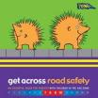

Your school will advise on the best software options

Hyperstudio 5 (20 Education Pack $A1,200.00)

HYPERSTUDIO / POWER POINT or CLAYMATION TASK – ROAD SAFETY

You are going to create a presentation that will teach very young students about road safety.

We will “borrow” a Year 7 class from school to evaluate your presentation.

Therefore, you MUST consider your audience’s needs and abilities very carefully.

You are going to work in a partnership of two or three people. NO MORE than 3.

They will be partners who will share the work, each person creating different elements of the final product. Find a partner (s) whose skills supplement and/or compliment your own, rather than duplicate your own. That is, widen your range of available skills!

1 Power Point (Used for this unit)

2 Hyperstudio worksheet

3 Claymation (Plastecine)

Students working at a higher level will obviously create more
topic “Powerpoint cards”, use a greater range of resources, provide evidence of greater skill and creativity in their work. Skilled and effective partnerships will create solutions for at least 5-6 topics:

- What the colours on traffic lights mean
- Look left, right, left before crossing the road
- Do not play on the road
- Hold the hand of an adult to cross the road
- Walk straight across the road, not on an angle
- What a cross-walk sign and road stripes looks like
- What a traffic lights flashing cross-walk sign looks like
- What a stop sign looks like
- What car indicators (to go left and right) look like
- Wearing seat belts
- Behaving sensibly in a car or bus
- Wearing bike helmets
- Any other road-safety rules or behaviours you think are important?

Other design requirements:

- Navigation/concept map created in Inspiration or Brainstorm (shows “webbed” navigation)
- provide a planning storyboard sketch for each page.
- a main menu that uses very simple metaphors to help students choose topics
- very simple navigation metaphors on each screen (including return to main menu)
- title screen
- help screen for teachers or parents to know how to use the presentation
- bibliography; credit/acknowledge your sources of information, software & hardware

Some web-sites to investigate for information and examples of road safety multimedia for children.

www.safetyart.com/animations.htm
Examples of simple animated gifs that you could replicate

www.ict.np.edu.sg/icthome/ictweb2004/showcase/simpleanimations.asp
select the short flash animations about road safety issues

www.lakemac.com.au/ForResidents/rs_cinema.asp
3 Little Pigs as a road safety message (vector animation with voiceovers); select “play movie”

www.highways.gov.uk/knowledge/tenth/?Click+me=Start
click the START button to see the choices on this website (more for 9-11 year olds)

www.rta.nsw.gov.au/roadsafety/parentsguide/index.html
You will need this page for background information on why we must teach road safety to kids

Set up a PowerPoint Road Safety.ppt for Road Safety get images from internet or make your own, hand drawn or created on the computer.
2. Cut and crop images

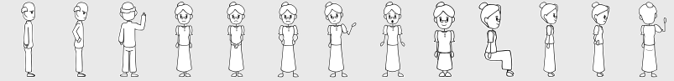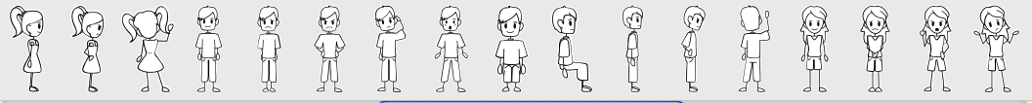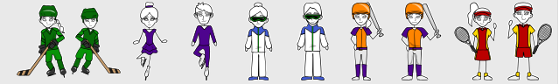
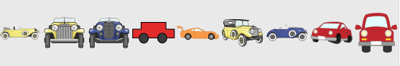
Find at least three more sites with your partners…..

Keep a list of any images or media you download from the web:

topic | File name | Media type | File size | source
Eg: road safety tips | safetytips.wav | audio | 230 Kb | www.rs4kids.org.au

Open Inspiration or use a paper brainstorm and create a detailed navigation map for your group to show how the “cards” of your Road safety “stack” will link together. Export it to .jpg , .pdf or .bmp and include it in your submission.

Make up a road safety power point using your skills with image manipulation and creative drawing techniques, the slide show should be fun, animated and logical, so you will need to plan well and work hard as a group to get your point across. A minimum of five (5) slides is required.

3. Make a Car Sticker for Road Safety:- size should be 15 cm x 8 cm approx and make up an appropriate slogan (10 marks)

Evaluation Individual Task
Copy to a new sheet and complete the form

Multimedia Task 4 – Safety Show

Devising
How did you plan your design – Storyboard, Brainstorm, Notes, Sketches, Just did it, other?
What did you do?
How did you do it?
Why

Investigating
What did you read or look up?
What did you do?
How did you do it?
Why

Producing
What software did you use? Did you use graphics, boxes, objects, clip art?
What did you do?
How did you do it?
Why

Evaluating
Have you completed this evaluation form and rated yourself? Yes/No
Product evaluation, I could improve my final product by:
What skills have you learnt?
How do you rate yourself? 1 – 10 (Excellent)
No (Low) Undecided Yes (High)
Rate yourself in the appropriate box: | 1 | 2 | 3 | 4 | 5 | 6 | 7 | 8 | 9 | 10
I found this task interesting
I have worked hard on this task
I have understood the task requirements
I enjoyed working on the task
I had enough time to complete the task
I had all the skills required to complete the task
I am happy with my finished product
I found it easy to find the information I required

Did you enjoy this task
Suggestions

Rate yourself on the following criteria

TEE subjects
(V outstanding, H very good, S satisfactory ND not demonstrated)

Whole School Select a level (4, 5 or 6)
For each box  Rate Your score in each based on the following: | Low Satisfactory High
 | 1 | 2 | 3 | 4 | 5 | 6 | 7 | 8 | 9 | 10

- Ability to locate information & research without any assistance
- Shows initiative
- Leadership/Planning Qualities
- Application to the task
- Time Management
- Works without any ‘nagging’ from the teacher

Did you personally enjoy investigation of your task?

- Yes
- No

What are some things you liked about this task?

What are some things you disliked about this task?

Any other comments you would like to make?
Hyperstudio You will include:
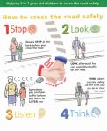

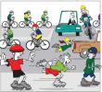

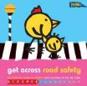

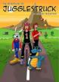

- Blabbermouth to speak information,
- Ghostwriter to write simple single words (eg: stop, go, left, right, wait)
- Hide-Show action scripting using HyperLogo to create roll-overs
- hot-spots (click-on areas) to act as buttons,
- buttons to create actions
- vector animations inserted as movies (use Corel RAVE)
- Stop-motion animations inserted as movies (use Quickcam)
- Web-cam movies (use QuickCam)
- Hyperstudio pathway animations (you drag-click to create the path)
- Text objects
- Graphics objects created in Corel PhotoPaint or Corel Draw
- Audio voiceover tracks created in Audacity
- Multimedia files exported and compressed using QuickTime

On separate screens (“cards” in Hyperstudio), the road-safety behaviours you are going to teach are chosen from this list.

Create a sketch plan of what aspect of safety you will teach

